Options of combining the individual fiber information from the “ctFIREout” folder

The options described here use screenshots from CT-FIRE 2.0/ CurveAlign 4.0, but they are also applicable in CT-FIRE 3.0/CurveAlign 5.0 with the same main features in terms of combining the CT-FIRE fiber features.

# Option 1:

In CurveAlign,1) choose the “CT-FIRE Fibers” mode to run the CurveAlign analysis, the features based on the individual fiber information will be calculated and saved into a “*fibFeatures.csv” file for each image in the “CA_Out” folder. This features file includes about 30 features including the individual fiber information imported from the ctFIREout folder, e.g. column 4-angle, column 6-length, column 8-straightness; column 9-width; 2) once the CurveAlign CT-FIRE fiber mode is done, click on the “Post-Processing” button, and choose the corresponding “CA_Out” folder (this folder can be renamed if you want to keep results from different analysis mode), and check the options. An example is shown below:

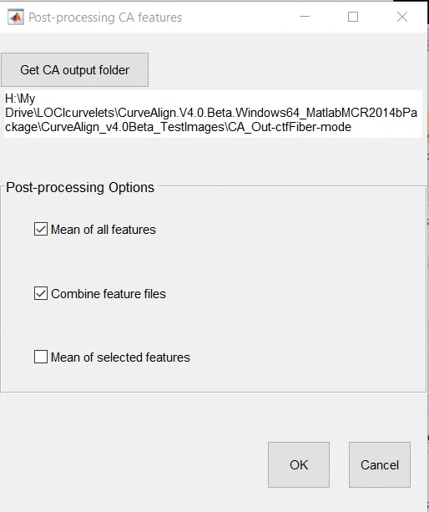

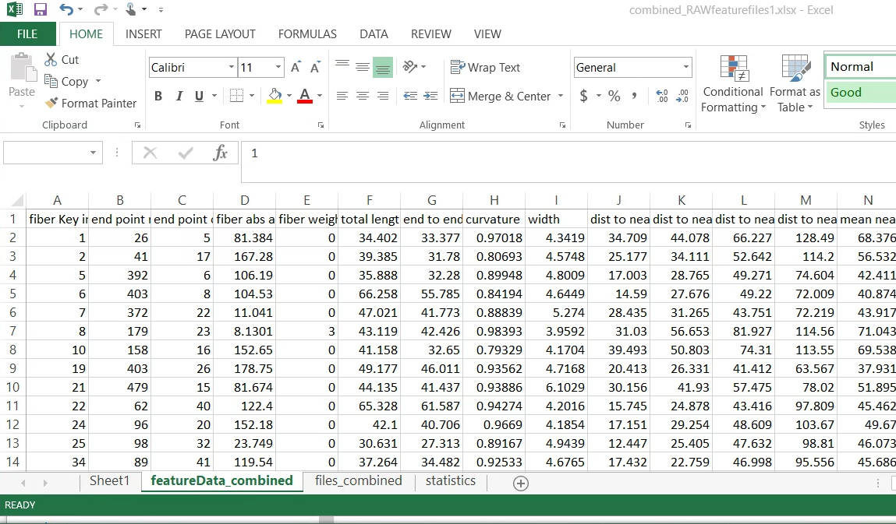

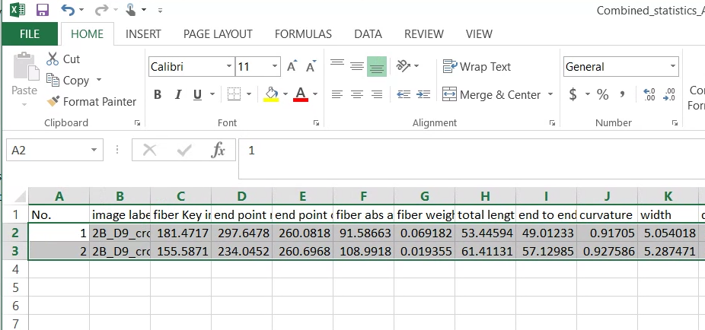

The combined file(s) will be saved in the corresponding “CA_Out*” folder.

# Option 2:

If the user only needs to combine the mean value of each feature, 1) Launch the “CT-FIRE” module from CurveAlign, then load the previous processed images by CT-FIRE, and choose to check the previous CT-FIRE results.

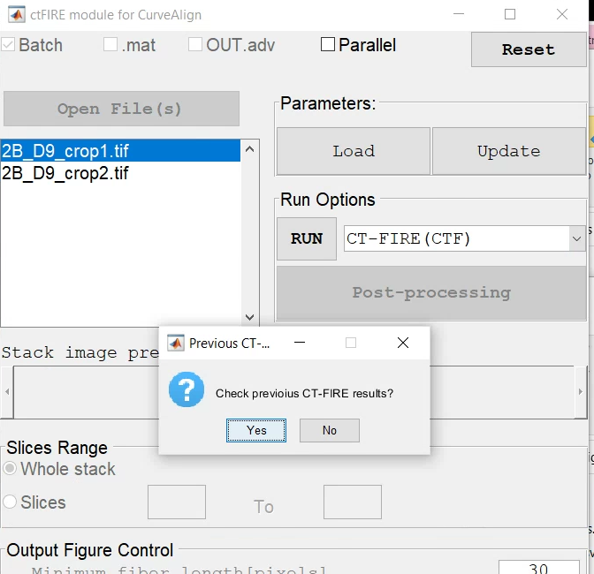

The mean value of each feature for all the opened images will be displayed in a table shown below:

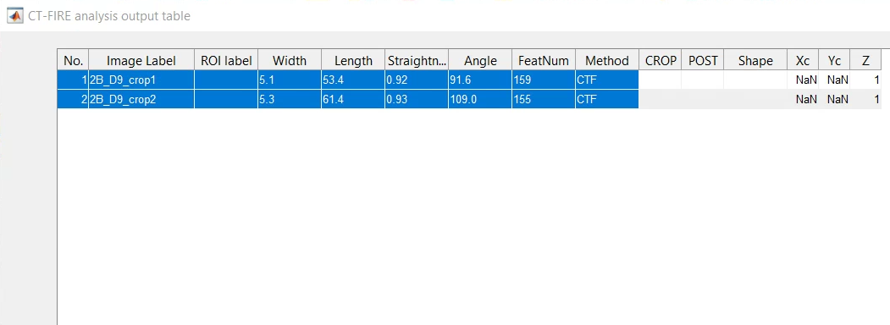

The user can select , copy and paste the data to an excel file.

# Option 3:

Download CT-FIRE 2.0/3.0 package from [“Curvelets” GitHub releases](https://github.com/uw-loci/curvelets/releases/) . Follow the Tutorial 3 in the manual (CT-FIRE 2.0/3.0) to use the advanced output control module to combine the CT-FIRE results.